Homepage - https://materializecss.com/getting-started.html

material icons - https://material.io/tools/icons/?style=baseline

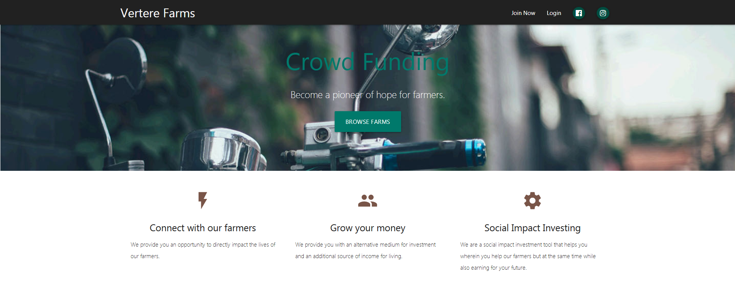

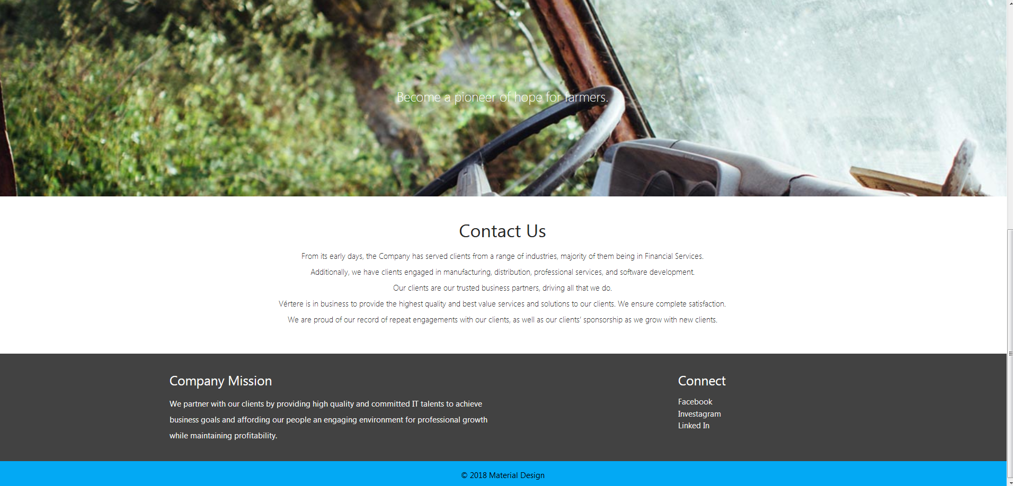

Farms

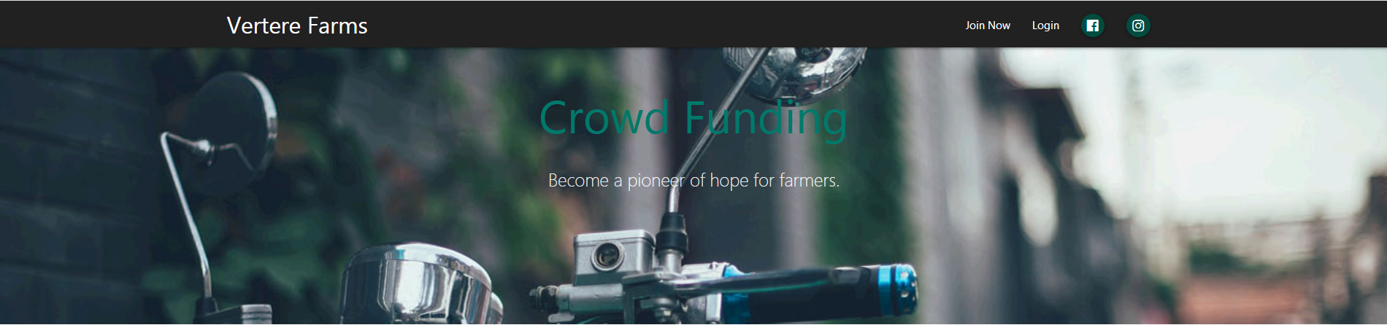

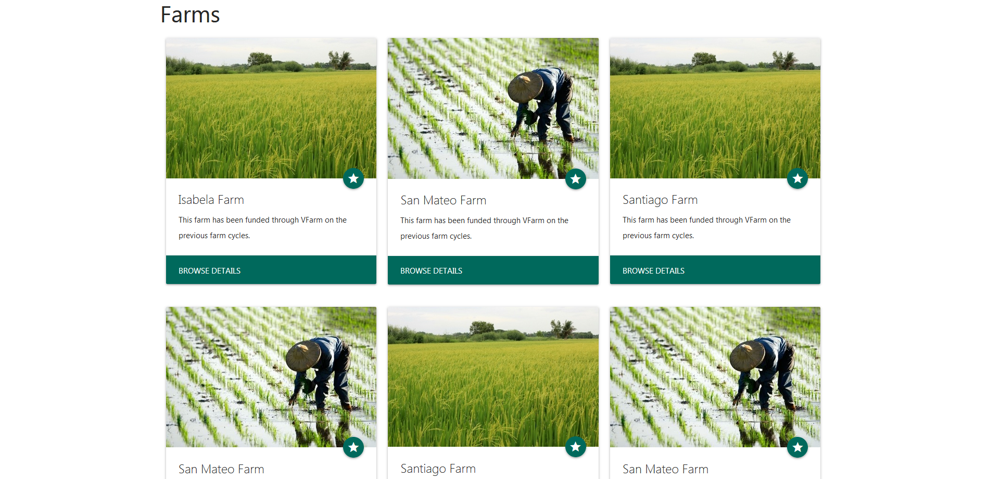



Login

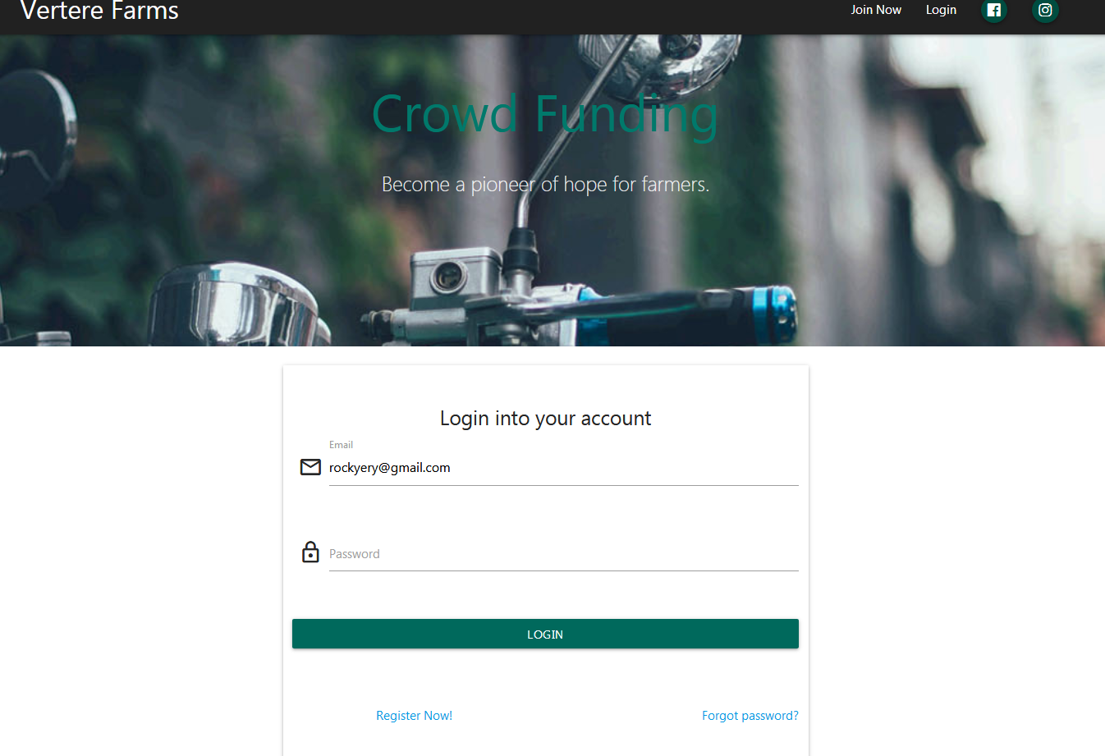

https://codepen.io/julianasobreira/pen/xVpxoO

Farm Products